Our Ref: _______________ Your Ref: ________________________ Date: __________________

Baptist Church

Baale Yaku Site Area, P. O. Box 644,

Ogbomoso, Oyo State. Tel. 07052425407

Email: [newsprinbaptistchurch@gmail.com](mailto:newsprinbaptistchurch@gmail.com)

Website: newspringbc.comze.com

NEW SPRING

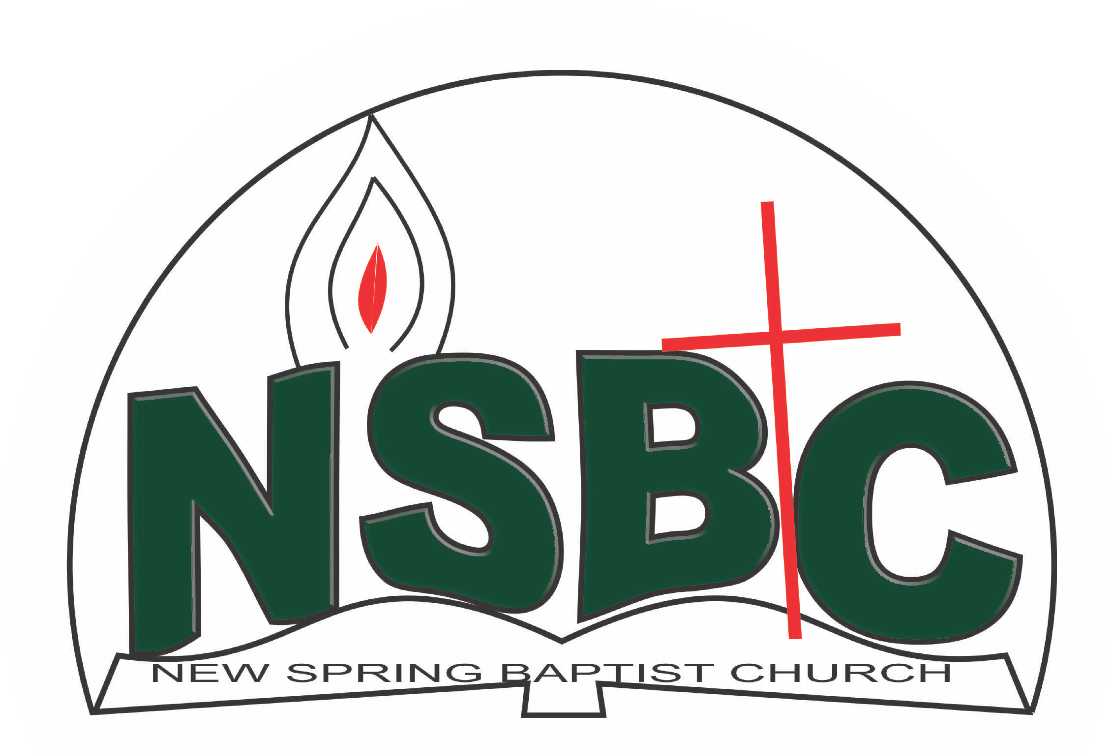

December 27, 2021

Dear Mrs. Bose Oke,

Nomination to Serve as a Worker in the Church in 2022

Greetings in the precious name of our Lord and Saviour Jesus Christ. It is our pleasure to inform you that at the Church-in-Conference held onDecember 19, 2021 the Church ratified your nomination to serve in the following areas between January 1 and December 31 2022:

1. Sunday School Teacher
2. Counselling& Follow-up Committee under the chairmanship of Dn. Christiana Oketoobo
3. Discipler
4. Member, Intercessors’ Committee under the chairmanship ofMrs. Funke Oyekunle
5. Member, Membership Committee under the chairmanship of Mr. Johnson Olaniran
6. Adviser, WMU
7. Matron, Youth Fellowship

Please refer to the table below for the key functions of each of these roles. Details can be found in the Church constitution. You are strongly encouraged to become familiar with the tasks as stated in the document. There will be an orientation of the Church workers on January 15, 2022 at 8:30 a.m. on the church premises. Please ensure you participate in this training.

“Now it is required that those who have been given a trust must prove faithful. I Corinthians 4:2”. May God find you faithful in the task He has assigned to you.

| Domain | Key function of Office, Department or Committee |
| --- | --- |
| Sunday School Teacher | To provide support to the Church Pastor in the teaching ministry of the Church to ensure that members and regular worshippers are well grounded in the Scriptures. |
| Member, Counsellling& follow-up Committee | To help decision makers understand and follow through on their decisions |
| Discipler | To provide support to the Church Pastor in the ministry of the Church to ensure that members and regular worshippers are well equipped for every good work. |
| Member, Intercessors Committee | The committee is responsible for standing in the gap on behalf of the Church and her members |
| Member, Membership Committee | Responsible for the overall management of the membership of the Church. |
| Adviser, WMU | To provide support to the Church Pastor in equipping the WMU of the Church for Christ-like life style and responsible mother. |
| Matron, Youth Fellowship | To provide support to the Church Pastor in counseling and equipping the youth of the Church for Christ-like life style and responsible adulthood. |

Thank you for accepting to serve in this Church.

Yours in His service

Olusayo Okediji Blessed Agboola

Church Secretary Chairman, Nominating Committee